PENETRATION TEST REPORT
PwnLab: init
VulnHub Vulnerable Machine — Assessment Report

Target | PwnLab: init (VulnHub) — 192.168.56.109
Assessment type | Controlled, educational penetration test (black-box)
Attacker system | Kali Linux — 192.168.56.40
Overall risk | Critical
Outcome | Remote code execution as www-data escalated to root
Report date | 5 November 2026
Prepared by | [Tester name]
Classification | Educational / lab use only

Table of Contents
1. Executive Summary 3
2. Scope and Environment 4
3. Methodology 4
4. Attack Chain Summary 5
5. Technical Walkthrough 5
5.1 Application and configuration discovery 5
5.2 Local file inclusion analysis 5
5.3 Upload handling and payload placement 7
5.4 Triggering the payload and initial access 8
5.5 Credential and account investigation 9
5.6 Privilege escalation 9
5.7 Completion 10
6. Detailed Findings 11
7. Remediation Roadmap 13
8. Limitations 13
Appendix A — Evidence Index 14

1. Executive Summary
This report documents a penetration test of PwnLab: init, an intentionally vulnerable virtual machine published on VulnHub. The objective was to gain a foothold on the host from the network and escalate privileges to root, then document each step, its security impact and how it should be remediated.
The assessment was successful. A chain of five weaknesses allowed an unauthenticated attacker to move from the public web application to full administrative control of the server:
- A local file inclusion (LFI) flaw let the tester read application source code, which exposed database credentials.
- An upload feature that relied on file extensions allowed a PHP payload to be stored as a GIF-suffixed file.
- The cookie-controlled include path was then used to execute that payload, returning a reverse shell as www-data.
- Database records and local accounts provided a route to the user accounts kane and mike.
- A SUID program (msgmike) vulnerable to PATH hijacking gave access to mike, and command injection in msg2root then produced a root shell.

Findings at a glance
ID | Finding | Severity | Evidence
F-01 | Cookie-controlled local file inclusion | High | Figures 2–4, 7
F-02 | Unsafe upload handling / executable content exposure | High | Figures 5–7
F-03 | Sensitive database configuration exposed | High | Figures 1, 3
F-04 | Database holds reusable account credential material | Medium–High | Figures 8–9
F-05 | Local privilege-escalation path (msg2root) | Critical | Figure 10

Evidence note
Some intermediate details — the exact upload request, full credential values and the precise privilege-escalation mechanism — are not fully visible in the supplied screenshots. They are therefore not asserted beyond what the evidence demonstrates.

2. Scope and Environment
Item | Detail
Target | PwnLab: init virtual machine (VulnHub)
Target address | 192.168.56.109
Attacking system | Kali Linux, 192.168.56.40 (as shown in reverse-shell evidence)
Application | PwnLab Intranet Image Hosting
Services observed | HTTP on TCP/80; MySQL accessed remotely during the assessment
Target operating system | Debian Linux (as reported by the shell)
Assessment type | Controlled, educational penetration test against an intentionally vulnerable VM

The evidence does not include a complete port-scan transcript, exact VM build details or all tool versions. Those details have not been inferred.

3. Methodology
The engagement followed a standard black-box penetration-testing workflow, from reconnaissance through post-exploitation and reporting.
# | Phase | Activity
1 | Reconnaissance | Identify the web application and review exposed pages and responses.
2 | Vulnerability analysis | Inspect page source and test the page parameter and lang cookie for file-inclusion behaviour.
3 | Exploitation | Upload a PHP payload with a GIF suffix and trigger it through the inclusion path.
4 | Post-exploitation | Enumerate the database and local accounts from the www-data shell.
5 | Privilege escalation | Pivot to local user accounts and execute msg2root to obtain root.
6 | Reporting | Document findings, impact and remediation.

4. Attack Chain Summary
The table below summarises the path from initial access to root. Each step is described in detail in Section 5.
Step | Stage | Result | Figures
1 | Information disclosure | PHP configuration snippet reveals MySQL host, database name Users and account root. | 1–3
2 | LFI discovery | Source shows the lang cookie concatenated into an include() path. | 2–4
3 | Payload upload | shell.php.gif uploaded via the image-hosting feature. | 5–6
4 | Payload execution | Crafted lang cookie includes the uploaded file; reverse shell received. | 7–8
5 | Account investigation | Users table lists kent, mike and kane; su to kane succeeds. | 8–9
6 | Privilege escalation | PATH hijack of SUID msgmike gives mike; command injection in msg2root gives root. | 10
7 | Completion | PwnLab completion banner displayed. | 11

5. Technical Walkthrough

5.1 Application and configuration discovery
The application was identified as PwnLab Intranet Image Hosting. A PHP configuration snippet exposed database connection settings: a local MySQL service, the database name Users and the database account root. The password is deliberately redacted in this report.
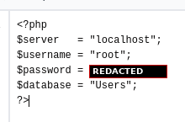
Figure 1. Database configuration disclosure (password redacted).

5.2 Local file inclusion analysis
The page parameter was first investigated as a possible file-inclusion vector. The browser evidence shows a PHP stream-wrapper style request being tested.
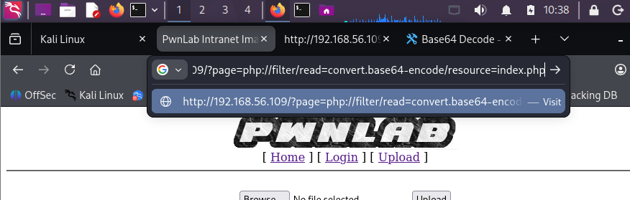
Figure 2. Page parameter tested with a PHP stream-wrapper request.
A base64 conversion stream was then used to retrieve application source and configuration output in readable form. The response includes the PwnLab page source and encoded content.
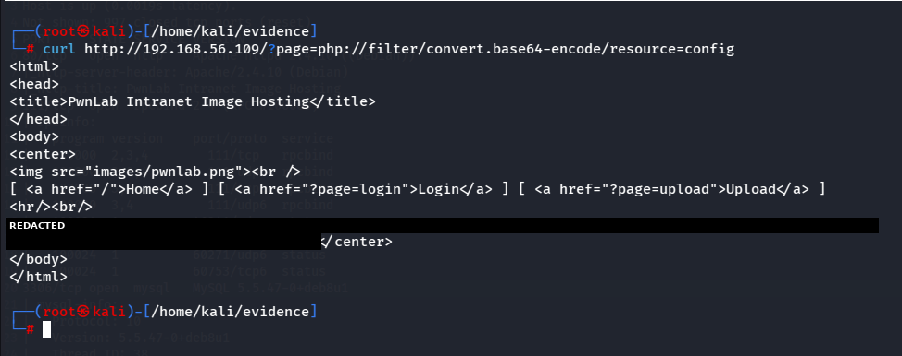
Figure 3. LFI payload and response inspection using a base64 conversion stream (encoded output redacted).
Inspection of the application source showed that the lang cookie is concatenated directly into an include path:
include("lang/" . $_COOKIE['lang']);
Because user-controlled cookie data influences the path passed to PHP’s include function, an attacker can cause arbitrary local files to be included. This is the key evidence for the cookie-controlled LFI path.
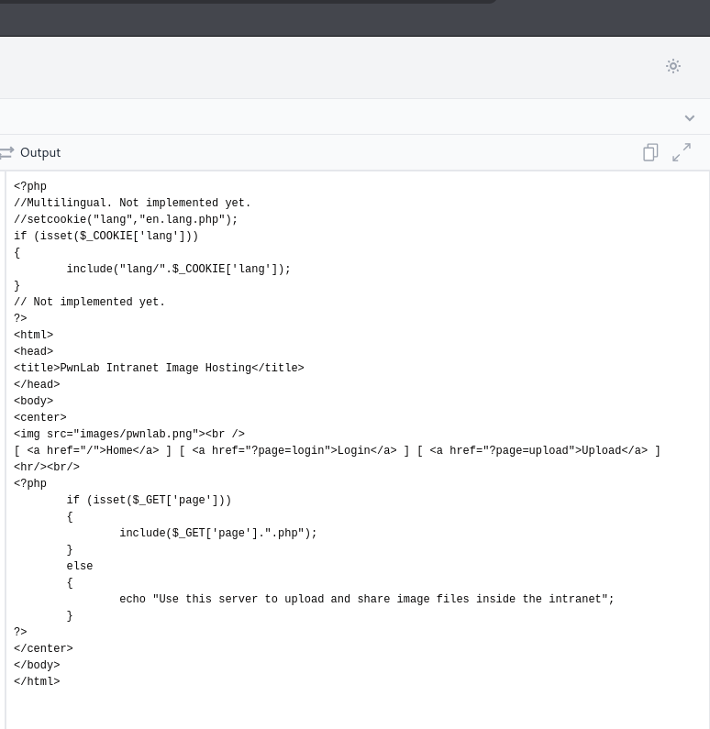
Figure 4. Application source showing the lang cookie used in an include() path.

5.3 Upload handling and payload placement
A PHP file was renamed to shell.php.gif and uploaded through the image-hosting functionality. The extension change alone does not establish how the server interpreted the file; the subsequent shell connection is the evidence of successful execution.
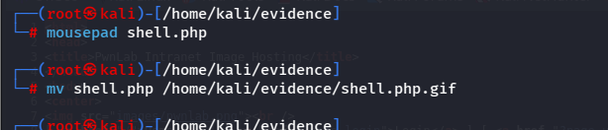
Figure 5. PHP shell renamed with a .gif suffix (shell.php.gif).
The page source then shows an uploaded file under the upload directory with a .gif extension, confirming the object was stored and referenced by the application.
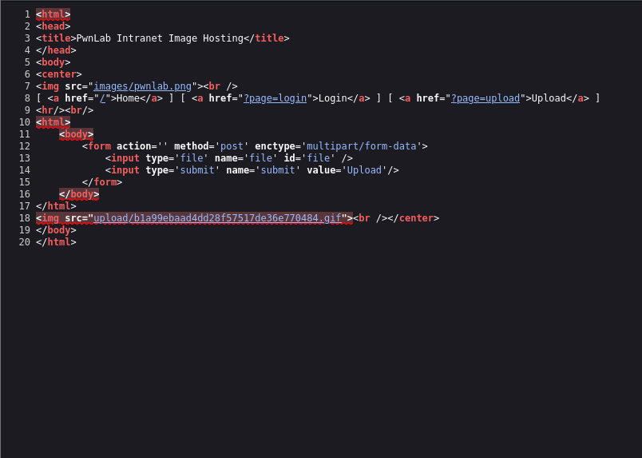
Figure 6. Uploaded GIF-suffixed file referenced from the upload directory.

5.4 Triggering the payload and initial access
A request was sent with a lang cookie containing a relative path into the upload directory and the uploaded GIF-suffixed payload. The curl output confirms the request was sent.
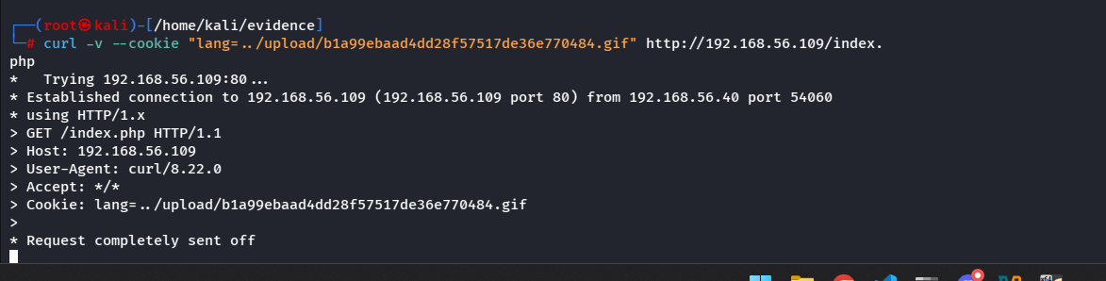
Figure 7. Request carrying a crafted lang cookie that points to the uploaded payload.
A listener on Kali received a connection from 192.168.56.109. The shell identified the target as Debian Linux and the process identity as uid 33 (www-data), confirming command execution in the web-server context.
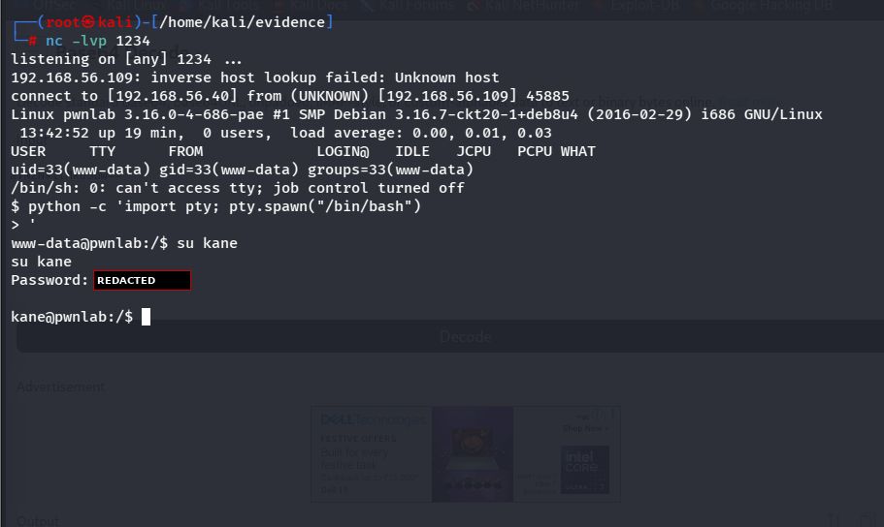
Figure 8. Reverse shell received as www-data (uid 33); su to kane (password redacted).

5.5 Credential and account investigation

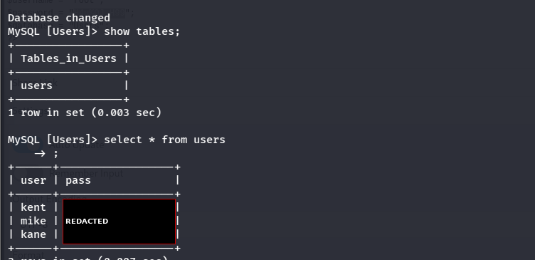
Figure 9. Users table listing kent, mike and kane (credential values redacted).

5.6 Privilege escalation
The terminal evidence in Figure 10 shows a two-stage escalation starting from the kane account:
- kane → mike. The home directory of kane contains msgmike, owned by mike with the SUID and SGID bits set (-rwsr-sr-x). The tester created an executable file named cat containing /bin/bash, prepended the current directory to PATH (export PATH=.:$PATH) and ran ./msgmike. The id command then returned uid 1002 (mike). This is consistent with msgmike calling cat without an absolute path.
- mike → root. In /home/mike, the program msg2root prompts for a message for root. Supplying input beginning with a shell separator (; /bin/sh) produced a root shell prompt (#), and whoami returned root. This is consistent with user input being passed to a shell command without sanitisation.
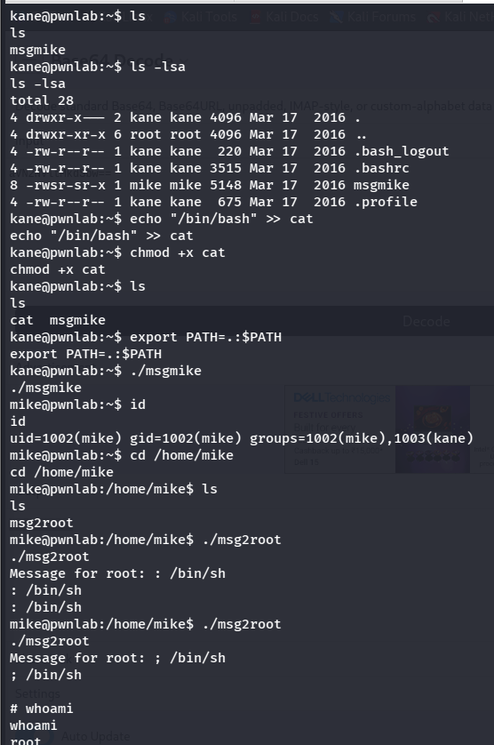
Figure 10. Privilege escalation from kane to mike to root.
Evidence note
The permission bits of msg2root and the source of both binaries are not shown. The root causes above are inferred from observed behaviour and should be confirmed by inspecting the binaries (for example with strings or ltrace) on the original VM.

5.7 Completion
A PwnLab completion banner confirms that the challenge was completed. The supplied image does not show a distinct flag value, so no flag string is included.
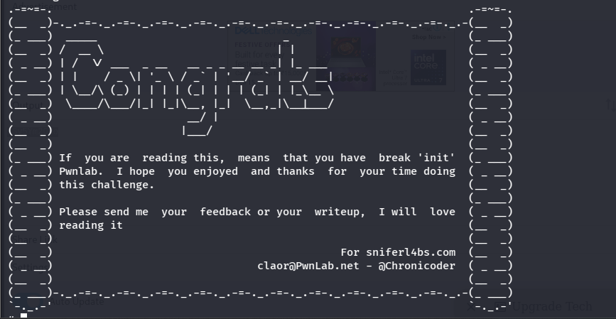
Figure 11. PwnLab challenge completion banner.

6. Detailed Findings

F-01 — Cookie-Controlled Local File Inclusion
Severity | High
Affected component | Language handling (lang cookie → include path)
Evidence | Figures 2–4, 7

Description. The application uses the lang cookie as part of a PHP include path without validation. The page parameter also accepted a PHP stream-wrapper style input during testing.
Impact. An attacker who controls the cookie can cause unintended local files to be included, enabling source-code disclosure or code execution depending on surrounding file-handling behaviour. Here it was combined with F-02 to obtain remote code execution.
Recommendation. Never build include paths from cookies or other user-controlled input. Map known language identifiers to fixed server-side filenames using a strict allowlist, and disable PHP stream wrappers where not required.

F-02 — Unsafe Upload Handling / Executable Content Exposure
Severity | High
Affected component | Image-hosting upload feature and upload directory
Evidence | Figures 5–7

Description. A PHP payload renamed with a GIF suffix was accepted by the upload feature and subsequently reached through the inclusion path. Validation based only on filename extension is insufficient.
Impact. Dangerous content can be stored on the server and later executed, giving an unauthenticated attacker code execution as the web-server account.
Recommendation. Store uploads outside the web root, validate content server-side (MIME and content inspection), generate server-side filenames, reject executable formats regardless of extension, and configure the web server so uploaded content cannot run as PHP.

F-03 — Sensitive Database Configuration Exposed
Severity | High
Affected component | PHP configuration file (database connection settings)
Evidence | Figures 1, 3

Description. A PHP configuration snippet disclosed the MySQL host, the database name Users and the privileged account root.
Impact. Exposed credentials can enable unauthorised database access if the service is reachable and the credentials are valid. MySQL was accessed remotely during the assessment.
Recommendation. Remove secrets from web-accessible source files, use a dedicated least-privilege database account instead of root, restrict database network exposure, and rotate any exposed credentials.

F-04 — Database Contains Reusable Account Credential Material
Severity | Medium–High
Affected component | Users database, users table
Evidence | Figures 8–9

Description. The users table holds the account names kent, mike and kane alongside password values that appear to be Base64-encoded rather than hashed. A su to kane reached a kane prompt.
Impact. If the stored values are weakly protected or reused, compromise of the database can lead to operating-system account compromise, as the account names in the database correspond to local users.
Recommendation. Store passwords with a modern, salted hashing function such as Argon2id or bcrypt, enforce strong unique credentials, and do not reuse application passwords for operating-system accounts.

F-05 — Local Privilege-Escalation Path
Severity | Critical
Affected component | msgmike (SUID mike) and msg2root
Evidence | Figure 10

Description. msgmike is SUID/SGID mike and appears to invoke cat via PATH, allowing a user-supplied cat to run as mike. msg2root then accepted shell metacharacters in its input and returned a root shell. Binary source and msg2root permission bits were not captured, so root causes are inferred from behaviour.
Impact. Any attacker able to reach the mike account can obtain full administrative control of the host, giving complete loss of confidentiality, integrity and availability.
Recommendation. Audit local executables for unnecessary SUID/SGID permissions. In custom programs use absolute paths for external commands, sanitise input, avoid shell invocation, and drop elevated permissions unless strictly required.

7. Remediation Roadmap
Recommendations are ordered by priority. Items that break the attack chain at its earliest stages should be addressed first.
# | Action | Addresses | Priority
1 | Replace cookie-built include paths with a strict allowlist of fixed filenames. | F-01 | Immediate
2 | Disable PHP stream-wrapper access where not required and confine includes to an approved directory. | F-01 | Immediate
3 | Store uploads outside the web root; validate content server-side; generate server-side filenames; reject executable formats. | F-02 | Immediate
4 | Prevent execution of uploaded content as PHP and apply least-privilege permissions to upload directories. | F-02 | Immediate
5 | Remove secrets from source files; use a least-privilege database account instead of root; rotate exposed credentials. | F-03 | Immediate
6 | Audit custom executables for unnecessary SUID/SGID bits and unsafe command execution; remove elevated permissions. | F-05 | Immediate
7 | Hash passwords with Argon2id or bcrypt using unique salts; enforce unique, strong credentials. | F-04 | Short term
8 | Run services with least privilege, patch the OS and application stack, and monitor web-server processes for unexpected child processes or outbound connections. | All | Ongoing

8. Limitations
This report is based only on the eleven screenshots supplied. It does not include a complete Nmap scan, full command history, raw HTTP request/response pairs, complete database output, the actual flag value or the source code of msgmike and msg2root.
Passwords, hashes and encoded configuration output visible in the original screenshots have been redacted (black boxes) to avoid reproducing secrets unnecessarily. The report distinguishes observed facts from interpretation and does not claim a specific CVE or an exact privilege-escalation root cause.

Appendix A — Evidence Index
Figure | Description | Section
1 | Database configuration disclosure | 5.1
2 | Page parameter stream-wrapper test | 5.2
3 | LFI payload and response inspection | 5.2
4 | lang cookie include() path in source | 5.2
5 | shell.php.gif filename change | 5.3
6 | Uploaded GIF-suffixed file referenced | 5.3
7 | Crafted lang cookie request | 5.4
8 | Reverse shell as www-data | 5.4
9 | Users table records | 5.5
10 | msg2root execution and root identity | 5.6
11 | Challenge completion banner | 5.7

